CRITICAL PATH METHOD (CPM)
20.1 Introduction
After the project network plan is constructed and activity times are known, the time analysis of the network becomes essential for planning various activities of the project as well as obtaining answers to questions like when the various activities are scheduled to be performed, how long it will take the project work to be completed and what are the crucial activities. In this lesson we will learn about computation of time estimates and determination of critical path.
20.2 Time Estimate Analysis
Time estimates analysis is a critical path in network analysis once the network of a project is constructed. Time analysis of network becomes essential for planning various activities of the project. An activity time is a forecast of the time and activity expected today from its starting point to it completion point (under normal conditions). The main objective of time analysis is to prepare a planning schedule of a project. Planning schedule should include the following factors.
i) Total completion time of the project.
ii) Earliest time and each activity start.
iii) Latest time each activity can be started without delaying the total project
iv) Float for each activity i.e. the amount of time by which the completion of an activity can be delaying the total project completion
v) Identification of critical activities and critical path.
20.3 Basic Notations
The following notations for basic scheduling computations will be used
( i−j) | = | Activity (i, j ) with tail event i and head event j.
T_{E} or E_{i} | = | Earliest occurrence time of event (j).
T_{L} or L_{f} | = | Latest allowable occurrence time of event (j).
D_{i j} | = | Estimated completion time of activity (i, j).
(E_{S}) _{i j} | = | Earliest starting time of activity (i, j)
(E_{f}) _{i j} | = | Earliest finishing time of activity (i, j).
(L_{s})_{i j} | = | Latest start time for activity (i, j).
(L_{f}) _{i j} | = | Latest finish time for activity (i, j).
20.4 Forward Pass Computation (For Earliest Event Time)
Before starting computations, the occurrence time of the initial network event is fixed. The forward pass computation computes the earliest start time (E_{s}) and earliest finish time (E_{f}) for each activity. The earliest time indicates the earliest time that a given activity can be scheduled and earliest finish time indicates the time by which the activity can be completed at the earliest. This is done in following three steps:
Step 1: The computations begin from the start node and move towards the end node. For the convenience in the forward pass computation start with an assumed earliest occurrence time equal to zero for the initial project events i.e. E₁=0
Step 2: i) Earliest starting time of activity (i, j) is the earliest event time of the tail event i.e.
ii) Earliest finish time of activity (i, j) is the addition of earliest starting time and the activity time i.e.
������������������
Step 3: Earliest event time for activity j is the maximum of the earliest finish time of all activities ending into that event. That is
��������������
����������������������������� 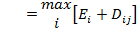
The computed values of E_{i} are put over the respective circles representing each event.
20.5 Backward Pass Computations (For latest allowable time)
The idea of the backward pass is to compute the latest allowable times of starting and finishing of each of the activities of a project without delaying the completion of the project. These can be computed by reversing the method of calculation used for earliest event time. This is done by using following steps
Step 1: For ending event it is presumed that E = L where all E�s are computed by previous method.
Step 2: Latest finish time for activity (i, j) is equal to the latest event time of event j. i.e., (L_{f}) _{ij}=L.
Step 3: Latest starting time for activity (i, j) is equal to latest completion time of (i, j) minus activity time (Ls)_{ij} = (L_{f})_{ij} � D_{ij}
Step 4: Latest event time for event i is a minimum of the latest start time of all activities originating from that event.
��������������
����������� 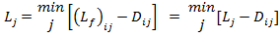
All the computed L values are put over respective circles representing each event.
20.6 Determination of Floats and Slack Times
When the network diagram is completely drawn, properly labeled and earliest (E) and latest (L) event times are computed, the next objective is to determine the floats and slack times defined as follows. There are three kinds of floats as given below :
20.6.1 Total float
The amount of time by which the completion of an activity could be delayed beyond the earliest expected completion time without affecting the overall project duration time. In other words, total float of an activity (i-j) is the difference between latest start time and earliest start time of that activity. Hence total float for activity (i-j) , denoted by (T_{f} )_{ij} is given as
����������� (T_{f})_{ij} = (Latest start-Earliest start) time for activity (i-j)
����������� (T_{f})_{ij} = (L_{s})_{ij} � (E_{s})_{ij} = (L_{f} � D_{ij}) - E_{i}
It refers to the amount of free time associated with an activity which can be used before, during or after the performance of this activity. This is the most important type of float because this is concerned with the overall project duration. Total float on critical activities is always taken as zero. The value of total floats for any activity is useful for drawing the following conclusions.
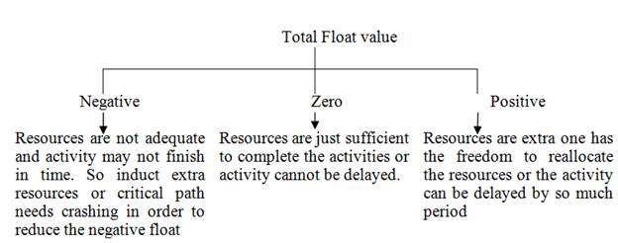
20.6.2 Free float
The time by which the completion of an activity can be delayed beyond the earliest finish time without affecting the earliest start of a subsequent (succeeding) activity. This is that value of the float which is consumable when the succeeding activities are started at their earliest starting times. Mathematically, free float for activity (i-j) denoted by (F_{f})_{ij} is calculated as (F_{f})_{ij} = (E_{j} � E_{i}) �D_{ij}
Free float for (i-j) = (Earliest time for event j � Earliest time for event i) � Activity time for (i-j).Thus free float is concerned with the commencement of subsequent activity.
(T_{f})_{ij} = (L_{j}− E_{i}) - D_{ij ,}but L_{j�} ≥ E_{i} as latest event time is always greater than equal to earliest event time. Therefore for all activities free float can take values from zero up to total float but will not exceed total float. Free float is always useful for rescheduling the activities with minimum disruption of earliest plan.
20.6.3 Independent float
The amount of time by which the start of an activity can be delayed without affecting the earliest start time of any immediately following activities, assuming that the preceding activity has finished at its latest finish time. Mathematically, independent float of an activity (i ,j) denoted by (I_{f})_{ij} can be calculated by the formula (I_{f})_{ij} = (E_{j} � E_{i}) � D_{ij}. The negative independent float is always taken as zero. This float is concerned with prior & subsequent activity. The independent float thus provides a measure of variation in starting time of a job without affecting preceding and succeeding activities.
Note:
� It can be observed that Independent float ≤ Free float ≤ Total float.
� The concept of float is useful for the management in representing underutilized resources and flexibility of the schedule and the extent to which the resources will be utilized on different activities.
� Float can be used for redeployment of resources to label the same or to reduce the project duration. Whenever a float in a particular activity is utilized the float of not only that activity but that of other activities would also change.
20.7 Slack of an Event
The basic difference between slack and float times is that slack is used for events only whereas float is applied for activities. For any given event, the event slack is defined as the difference between the latest event and earliest event times. Mathematically, for a given activity (i-j)
Head event slack = L_{j} � E_{j} and Tail event slack = (L_{i} � E_{i})
All the floats defined earlier can be defined in terms of head or tail events slack as under:
����������� Total float = L_{j} � E_{i} � D_{i}
����������� Free float = (E_{j} � E_{i} � D_{ij}) = (L_{j} � E_{i} � D_{ij}) � (L_{ij} � E_{ij}) = Total float � Head event slack
����������� Independent float =E_{j} � L_{i} � D_{ij}= (E_{j} � E_{i} � D_{ij})�(L_{i}�E_{i})= Free float � Tail event slack
20.8 Determination of Critical Path
After determining the earliest and latest scheduled times for various activities, the next step is to find the minimum time required for the completion of whole project. Before defining this let us first discuss about the meaning of critical event and critical activity.
20.8.1 Critical event
The slack of an event is the difference between latest and earliest event time i.e. Slack (i) = L_{i} � E_{i}. The event with zero slack time is called critical event. In other words, the event (i) is said to be critical when L_{i} = E_{i}
20.8.2 Critical activity
Since the difference between the latest Start time & earliest start time of an activity is usually called as total float. Activity with zero total float are known as critical activities. In other words, an activity is said to be critical if its delay in its start will cause a further delay in the completion date of entire project.
20.8.3 Non-critical activity
A non-critical activity is such that the time between its earliest start and its latest completion date is longer than its actual duration.
20.8.4 Critical path
The sequence of critical activity in a network is called a critical path. This path is the longest path in the network from the starting event to the end of event and defines the minimum time required to complete the project. The term path is defined as a sequence of activities such that it begins at the starting event and end at the final event. The length of the path is the sum of the individual time of the activities lying on the path. If the activities on critical path are delayed by a day, the project would also be delayed by a day unless the time of the future critical activity is reduced by a day by different means. The critical path is denoted by double or darker lines in order to distinguish from the other non critical path.
20.8.4.1 Main features of critical path
� If the project has to be shortened then some of the activities on that path must also be shortened. The application of additional resources on other activities will not give the desired results unless that critical path is shortened first.
� The variation in actual performance from the expected duration time will be completely reflected in one to one fashion in anticipation completion of the whole project.
� It plays an important role in scheduling and controlling large projects.
� It identifies all the critical activities of the project.
The computation procedure used for the time analysis of the project is described in the examples 1and 2
Example 1
Draw a network diagram of the following schedule of activities and find its critical path. Also calculate slack time for each event
Activity | 1-2 | 1-3 | 1-4 | 2-6 | 3-7 | 3-5 | 4-5 | 5-9 | 6-8 | 7-8 | 8-9
Duration  (in days) | 2 | 2 | 1 | 4 | 5 | 8 | 3 | 5 | 1 | 4 | 3

Solution
First construct the network diagram which is depicted in fig. 20.1
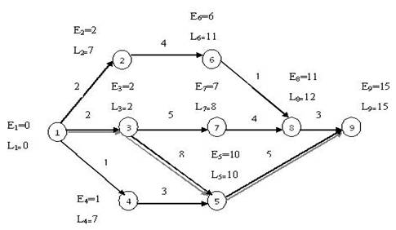
Fig. 20.1 Network diagram
To determine the critical path, compute the earliest start E_{i} and latest finish L_{j} for each activity (i, j)
Forward Pass Computation (For earliest time event): As shown in fig. 20.1 assuming E₁=0 and E₂=E₁+D₁₂=0+2=2, E₃=E₁+D₁₃=0+2=2 and E₄=E₁+D₁₄=0+1=1
����������� E₆=E₂+D₂₆=2+4=6, E₇=E₃+D₃₇=2+5=7
����������� 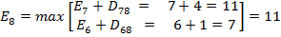
����������� 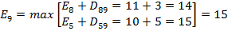
From this computation it can be inferred that this project will take 15 days to complete.
Backward Pass computations (For latest allowable time): In backward computation method assign the latest allowable time determined in forward pass computation method i.e. put L₉=15
����������� L₈=L₉-D₉₈=15-3=12, L₆=L₈-D₈₆=12-1=11, L₇=L₈-D₈₇=12-4=8
����������� L₅=L₉-D₉₅=31-6=25,
�������������� 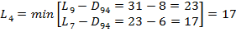
����������� L₄=L₅-D₅₄=10-3=7 L₂=L₆-D₆₂=11-4=7
�������������� 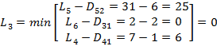
The path 1-3-5-9 is the critical path which is shown in Fig. 20.1 with double lines joining all those events where E_{i}=L_{j} The total duration of project is equal to 2+8+5=15 days
Computation of Float: For each non �critical activity, the total float, free float and independent float calculations are given Table 20.1
Table 20.1 Calculations of time estimates and floats
Activity  (i-j)  (1) | Duration  D_{ij}  (2) | Start |  | Finish |  | Float
 |  | Earliest  (3) | Latest  (4)=(6)−(2) | Earliest (5)  = (3) + (2) | Latest  (6) | Total (7)  =(4) - (3) | Free (8)  =(5) - (3) -(2) | Independent (9)= (8) - [(3)-(2)]
1-2 | 2 | 0 | 5 | 2 | 7 | 5 | 0 | 0
1-3 | 2 | 0 | 0 | 2 | 2 | 0 | 0 | 0
1-4 | 1 | 0 | 6 | 1 | 7 | 6 | 0 | 0
2-6 | 4 | 2 | 7 | 6 | 11 | 5 | 0 | 0
3-7 | 5 | 2 | 3 | 7 | 8 | 1 | 0 | 0
3-5 | 8 | 2 | 2 | 10 | 10 | 0 | 0 | 0
4-5 | 3 | 1 | 7 | 4 | 10 | 6 | 6 | 0
5-9 | 5 | 10 | 10 | 15 | 15 | 0 | 0 | 0
6-8 | 1 | 6 | 11 | 7 | 12 | 5 | 4 | 0
7-8 | 4 | 7 | 8 | 11 | 12 | 1 | 0 | 0
8-9 | 3 | 11 | 12 | 14 | 15 | 1 | 1 | 0
Example 2
Draw the network diagram for the following project and find the critical path and maximum time for completion of the project.
Activity |  | A | B | C | D | E | F | G | H | I | J | K | L
Preceded by |  | - | A | A | B | B | C | C | F | D | G, H | E | I
Duration (weeks) |  | 10 | 9 | 7 | 6 | 12 | 6 | 8 | 8 | 4 | 11 | 5 | 7

Solution
Network diagram of the above problem is shown in Fig. 20.2.

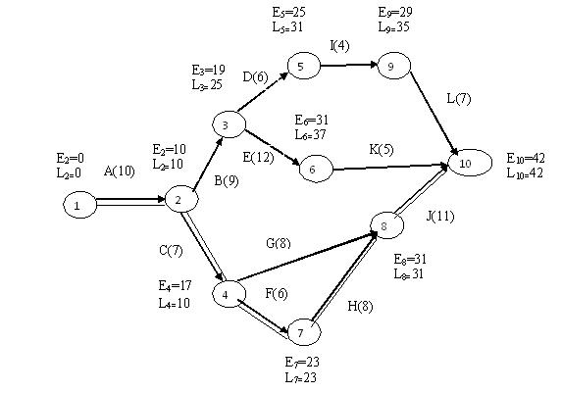
Fig. 20.2 Network diagram
To determine the critical path, compute the earliest start E_{i} and latest finish time L_{j} for each activity (i,j).The calculations are given below
Forward Pass Computation (For earliest time event): As shown in fig 20.2 assuming E₁=0 and E₂=E₁+D₁₂=0+10=10, E₃=E₂+D₂₃=10+9=19, E₄=E₂+D₂₄=10+7=17, E₅=E₃+D₃₅=19+6=25, E₆=E₃+D₃₆=19+12=31, E₇=E₄+D₄₇=17+6=23,
����������� 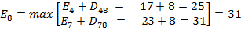

����������� E₉=E₅+D₅₉=25+4=29,

�������������� 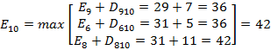

From this computation it can be inferred that this project will be completed in 42 weeks.
Backward Pass computations (For latest allowable time): In backward computation method assign the latest allowable time determined in forward pass computation method i.e. put L₁₀=42
����������� L₉=L₁₀-D₁₀₉=42-7=35, L₆=L₁₀-D₁₀₆=42-5=37, L₈=L₁₀-D₁₀₈=42-11=31,
����������� L₅=L₉-D₉₅=35-4=31, L₇=L₈-D₈₇=31-8=23
����������� 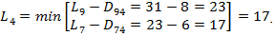

�������������� 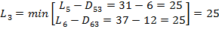
����������� 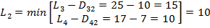

����������� L₁=L₂-D₂₁=10-10=0
The path 1-2-4-7-8-10 is the critical path which shown in Fig. 20.2 with double lines joining all those events where E_{i}=L_{j} The total duration of project is equal to 10+7+6+8+11=42 weeks

Activity  (i-j)  (1) | Duration  D_{ij}  (2) | Start |  | Finish |  | Float
 |  | Earliest  (3) | Latest (4)  = (6)−(2) | Earliest (5)  =(3)+(2) | Latest  (6) | Total (7)  =(4) - (3) | Free (8)=  (5) -(3) - (2) | Independent (9)= (8) - [(3)-(2)]
A(1-2) | 10 | 0 | 0 | 10 | 10 | 0 | 0 | 0
B(2-3) | 9 | 10 | 16 | 19 | 25 | 6 | 0 | 0
C(2-4) | 7 | 10 | 10 | 17 | 17 | 0 | 0 | 0
D(3-5) | 6 | 19 | 25 | 25 | 31 | 6 | 0 | 0
E(3-6) | 12 | 19 | 25 | 31 | 37 | 6 | 0 | 0
F(4-7) | 6 | 17 | 17 | 23 | 23 | 0 | 0 | 0
G(4-8) | 8 | 17 | 23 | 25 | 31 | 6 | 6 | 0
H(7-8) | 8 | 23 | 23 | 31 | 31 | 0 | 0 | 0
I(5-9) | 4 | 25 | 31 | 29 | 35 | 6 | 2 | 0
J(8-10) | 11 | 31 | 31 | 42 | 42 | 0 | 0 | 0
K(6-10) | 5 | 31 | 37 | 36 | 42 | 6 | 6 | 0
L(9-10) | 7 | 29 | 35 | 36 | 42 | 6 | 6 | 0

20.9 Critical Path Method (CPM)
Critical Path Method (CPM) , was developed by M.R.Walker and J. E. Kelly. They came up with arrow diagram as the most logical representation of the interrelationships between the jobs in a project to be executed in a well defined sequence. The arrow diagram designed by them, as well as the method of calculating the critical path are the same as in PERT network, except that they used the single time estimate and did not enter the problem of uncertainty of the duration of time for the individual jobs.
CPM emphasizes the relationship between applying more men or other resources to shorten the duration of given jobs in a project and the increased cost of these additional resources. With CPM the amount of time needed to complete various parts of the project is assumed to be known with certainty. Moreover, the relation between the amount of resources employed and the time needed to complete the project is also assumed to be known. The interactive procedure of determining the critical path involves the following steps:
i) Break down the project into various activities systematically. Label all activities. Arrange all the activities in logical sequence. Construct the arrow diagram.
ii) Number all the nodes (events) and activities. Find the time for each activity considering it to be deterministic. Indicate the activity times on the arrow diagram.
iii) Calculate earliest start time, earliest finish time, latest start time and latest finish time. Tabulate activity normal times, earliest time and latest time.
iv) Determine the total float for each activity by taking difference between the earliest time and the latest time for each node.
v) Identify the critical activities (the activities with zero float) and connect them with the beginning node and the ending node in the network diagram by double line arrow. This gives the critical path.
vi) Calculate the total project duration.

RULES FOR DRAWING NETWORK ANALYSIS
19.1 Introduction
A fundamental ingredient in both PERT and CPM is the use of network systems as a means of graphically depicting a project. When a network is being constructed, certain conventions are followed to represent a project graphically, for it is essential that the relationship between activities and events are correctly depicted. Drawing a network diagram is a relatively easy task, and can be accomplished by listing each task on a piece of paper and representing the sequence in which the tasks take place. Lines and arrows are drawn between the pieces of paper to show which tasks follow on from others. The diagram aims to portray how the tasks relate to one another i.e. which tasks have to be completed before others begin and which tasks can be performed simultaneously. Creating the network is an iterative process and may involve a number of revisions before an optimum solution is found.
19.2 Sequencing
The initial step in project scheduling process is the determination of all specific activities that comprise the project and their interdependence relationships. In order to make a network following points should be taken into consideration.
- What job or jobs precede it?
- What job or jobs run concurrently?
- What job or jobs follow it?
- What controls the start and finish of a job?
Since all further calculations are based on the network, it is necessary that a network be drawn with full care. There are many ways to draw a network, in this lesson we will describe the method which follows the precedence table. The following example of preparation of Paneer (Cottage cheese) shows the basic steps required in drawing a network.
Example 1
For preparation of Paneer (Cottage Cheese) the following list represents major activities
i) Receive whole cow/buffalo milk
ii) Standardize milk to obtain desired level of fat percentage
iii) Take citric acid and prepare 1% solution
iv) Heat the citric acid to 70 º C
v) Bring the standardized milk to boil on medium heat
vi) Cool the milk to 70 º C and add slowly the solution of citric acid till yellowish whey separates
vii) Strain the mixture through a clean muslin cloth.
viii) Hold it under running water for a minute and then press out the excess water.
ix) Hang the muslin for 15-20 minutes so that all the whey is drained out.
x) Prepare mould to form Paneer block
xi) Fill the mass into the block and tie the muslin
xii) Place it under something heavy for up to two hours
xiii) Cut the paneer into chunks and used as required.
Based on above list of different activities a precedence table may be formed which is given in Table 19.1
Table 19.1 Precedence table
Activity | Description | Preceding Activity
A | Receive whole cow/buffalo milk | -
B | Standardize milk to obtain desired level of fat percentage | A
C | Take citric acid and prepare 1% solution | -
D | Heat the citric acid to 70 º C | C
E | Bring the standardized milk to boil on medium heat | B
F | Cool the milk to 70 º C and add slowly the solution of citric acid till yellowish whey separates. | D,E
G | Strain the mixture through a clean muslin cloth. | F
H | Hold it under running water for a minute and press out the excess water. | G
I | Hang the muslin for 15-20 minutes and drain out all the whey. | H
J | Prepare mould to form Paneer block | H
K | Fill the mass into the block and tie the muslin | J
L | Place it under something heavy for up to two hours. | K
M | Cut the paneer into chunks and use as required. | L
In the above table due consideration has been given to precedings of an activity. While drawing the network, other factors will be considered. The activity A has no preceding activity and it is represented by an arrow line (Fig. 19.1). Likewise activity C has no preceding activity and both activities A and C can be done simultaneously so they are shown as concurrent activities. Activities B and D are preceded by the activities A and C respectively. The complete network is shown in Fig 19.1
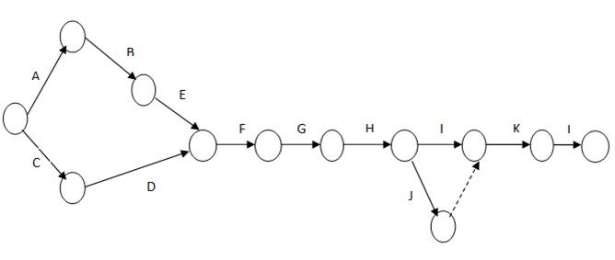
Fig. 19.1 Network diagram
19.3 Guidelines for Drawing Network Diagram
There are number of rules in connection with the handling of events and activities of a project network which are given below:
a) Each activity is represented by one and only one arrow in the network. This implies that no single activity can be represented twice in the network. This is to be distinguished from the case where one activity is broken into segments. In such a case each segment may be represented by a separate arrow.
b) No two activities can be identified by the same beginning and end event. In such cases, a dummy activity is introduced to resolve the problem as shown in Fig. 19.2
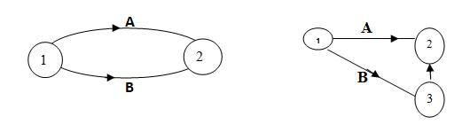
Fig. 19.2 Using a dummy activity
c) In order to ensure the correct precedence relationship in arrow diagram following question must be checked whenever any activity is added to a network.
What activity must be completed immediately before this activity can start?
What activities must follow this activity?
What activities must occur simultaneously with this activity?
d) Thus a network should be developed on the basis of logical or technical dependence.
e) The arrows depicting various activities are indicative of logical precedence only; hence length and bearing of the arrows are of no significance.
f) The flow of the diagram should be from left to right.
g) Two events are numbered in such a way that the event of higher number can happen only after the event of lower number is completed.
h) Arrows should be kept straight and not curved. Avoid arrow which cross each other.
i) Avoid mixing two directions vertical and standing arrows may be used if necessary.
j) Use dummy activity freely in rough graph but final network should have only reluctant dummy.
k) The network has only one entry point called the start event and one point of emergence called end event.
l) Angle between the arrows should be as large as possible.
19.4 Error in Drawing Network
There are three types of errors which are common in network diagrams
19.4.1 Dangling error
To disconnect an activity before the completion of all activities in a network diagram is known as dangling.
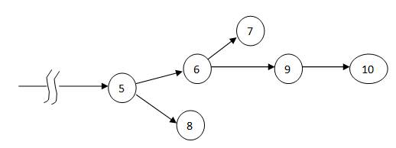
Fig. 19.3 Dangling error
In Fig. 19.3 the activity 5 to 8, 6 to 7 are known as dangling error. These are not last activities in the network.
19.4.2 Looping error
Looping error is also known as cyclic error in the network. Drawing an endless loop in a network diagram is known as error of looping as shown in Fig. 19.4
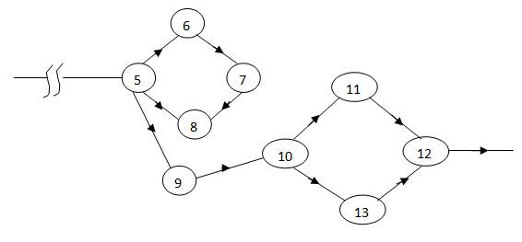
Fig. 19.4 Appearance of a loop in the network
19.4.3 Reductancy error
Unnecessarily inserting the dummy activity in a network diagram is known as error of reductancy as shown in Fig 19.5 in which putting an dummy activity from 10 to 12 is a reductancy error.
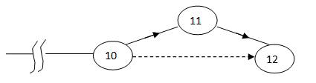
Fig. 19.5 Reductancy error
19.5 Labeling of a Network Diagram
For network representation it is necessary that various nodes be properly labeled. For convenience, labeling is done on a network diagram. A standard procedure called i-j rule developed by D.R.F Fulkerson is most commonly used for this purpose.
Fulkerson�s i-j Rule
Step 1: First, a start event is one which has arrows emerging from it but not entering it. Find the start event and label it as number1.
Step 2: Delete all arrows emerging from all numbered events. This will create at least one new start event out of the preceding events.
Step 3: Number all new start events �2�, �3� and so on. No definite rule is necessary but numbering from top to bottom may facilitate other users using the network when there are more than one new start event.
Step 4: Go on repeating step no. 2 & 3 until the end reached.
These rules are illustrated by taking into consideration the Example 19.1 and network diagram as shown in Fig.19.6
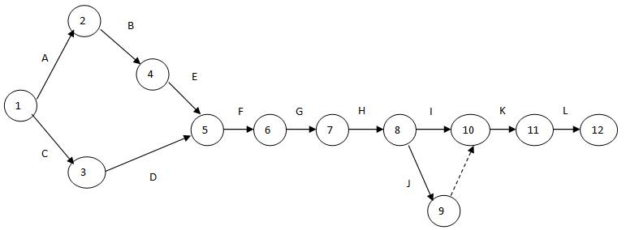
Fig. 19.6 Network diagram of preparation of paneer

PROJECT EVALUATION AND REVIEW TECHNIQUE (PERT)
21.1 Introduction
The network method discussed so far may be termed as deterministic, since estimated activity times are assumed to be known with certainty. While this assumption holds for the CPM analysis. In most of the projects, these activity times are random variables. A new technique known as Project Evaluation and Review Technique (PERT) was devised in 1958 for the POLARIS missile program by the Program Evaluation Branch of the Special Projects office of the U. S. Navy, helped by the Lockheed Missile Systems division and the Consultant firm of Booz-Allen & Hamilton.
21.2 Project Evaluation & Review Technique (PERT)
In research project of designing a new machine or development of a new dairy product, various activities to be performed are based on judgment. A reliable time estimate is difficult to get because the technology is changing rapidly. Time values are subjected to variation. The main objective of the analysis through PERT is to find out the completion for a particular event within specified date. What are the chances of completing the job? This approach takes into account uncertainties. In this approach three time values are estimated with each activity: Optimistic time, most likely time and Pessimistic time. The three time values provide a measure of uncertainty associated with that activity.
21.2.1 Optimistic time
It is the shortest possible time in which the activity can be finished and assumes that everything goes very well. In other words, it is the estimate of the minimum possible time, which an activity takes to complete under ideal conditions i.e. no provision are made for breakdown, delays etc. They are generally denoted by (t₀) or (a).
21.2.2 Most likely time
This is estimate of the normal time the activity would take. This assumes normal delays. It is denoted by (t_{m}) or (m). If a graph is plotted between the time of completion and frequency of completion in that period, the highest frequency of occurrence is denoted by most likely time as shown in Fig. 21.1.
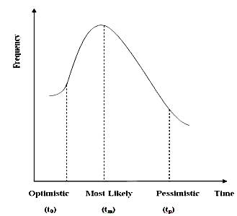
Fig. 21.1 Time distribution curve
21.2.3 Pessimistic time
The longest time, the activity could take if everything goes wrong. In other words, it is the longest time the activity can conceivably take. This is generally denoted by (t_{p}) or (b).
The three time values are shown in Fig. 21.1.
The PERT technique makes the following assumptions:
� Activity times are statistically independent and usually associated with �beta� distribution.
� There are enough activities involved in the network and totals of activity times based on their means and variances will be normally distributed.
� The three estimates of the activity duration can be obtained for each activity.
In PERT calculation, all values are used to obtain the expected value.
21.2.4 Estimated time
This is the average time an activity will take if it is to be repeated large number of times and is based on the assumption that the activity time follows Beta distribution.
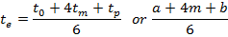
21.2.5 Variance
Variance of each activity is given by formula:
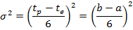
where t_{o} (a) , t_{p} (b) and t_{m}(m) are optimistic , pessimistic and mostly likely times respectively.
Once the expected times of the activities are obtained, the critical path of the project network is determined using three time estimates. Having found the critical path, the PERT methodology assumes that the aggregation of the mean times and the summation of the variances of critical jobs would yield the expected project duration and its variance. PERT uses the variance of critical path activity to help in determining the variance of the overall project. Project variance is computed by summing variance of just critical activities.
21.3 PERT Algorithm
The various steps involved in the PERT network for analyzing any project are summarized below:
i) Develop a list of activities involved in the project including the immediate predecessors.
ii) Draw the network diagram using the rules and conventions as discussed before.
iii) Number the events in ascending order from left to right
iv) From the three time estimates compute the expected time (t_{e}) for each activity using the formula
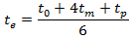
Using the expected activity time estimates, determine the earliest start time and earliest finish time for each activity .
v) Compute the latest start time and latest finish time and the float associated with each activity. Find the activities with zero total float which are known as critical activities. From these critical activities find the critical path.
vi) Using the value for t_{p} (b) and t_{o}(a) , calculate the variance (σ²) by using the formula

vii) Use the variability in the activity times to estimate the variability of the project completion date; using this estimate compute the probability of meeting a specified date by using the standard normal equation
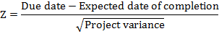
where Z is a standard normal variate

21.4 Illustrative Examples on PERT
The computation procedure used for PERT is described in the examples 1and 2
Example 1:
A small project is composed of nine activities whose time estimates are listed in the following table:
Activity | t₀ | t_{p} | t_{m}
1-2 | 5 | 10 | 8
1-3 | 18 | 22 | 20
1-4 | 26 | 40 | 33
2-5 | 16 | 20 | 18
2-6 | 15 | 25 | 20
3-6 | 6 | 12 | 9
4-7 | 7 | 12 | 10
5-7 | 7 | 9 | 8
6-7 | 3 | 5 | 4

a) Find the expected task time and their variance.
b) Earliest and latest expected time of each node.
c) Critical path
d) Probability that project will complete in 41.5 weeks and 44 weeks.

Solution:
The expected task time and variances of different activities are computed by the following formulae:
and
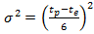
and these values are given in following table

Activity | t₀ | t_{p} | t_{m} | 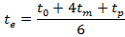 | 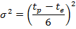
1-2 | 5 | 10 | 8 | 47/6 | 25/36
1-3 | 18 | 22 | 20 | 20 | 16/36
1-4 | 26 | 40 | 33 | 33 | 196/36
2-5 | 16 | 20 | 18 | 18 | 16/36
2-6 | 15 | 25 | 20 | 20 | 100/36
3-6 | 6 | 12 | 9 | 9 | 36/36
4-7 | 7 | 12 | 10 | 59/6 | 25/36
5-7 | 7 | 9 | 8 | 8 | 4/36
6-7 | 3 | 5 | 4 | 4 | 4/36

Construct the network diagram showing earliest and latest expected time of each node.
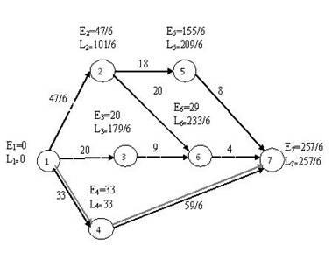

Rule to find out variance of Events:-
We take initial value of variance V₁ = 0
- 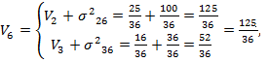
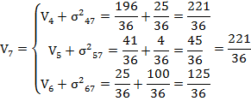
NOTE: At merge point the variance is computed along the longest path in case of two path having the same length the larger of the two variance of that event.
Critical path is 1-4-7 and total duration is 257/6 = 42.833 weeks with variance = 221/36=

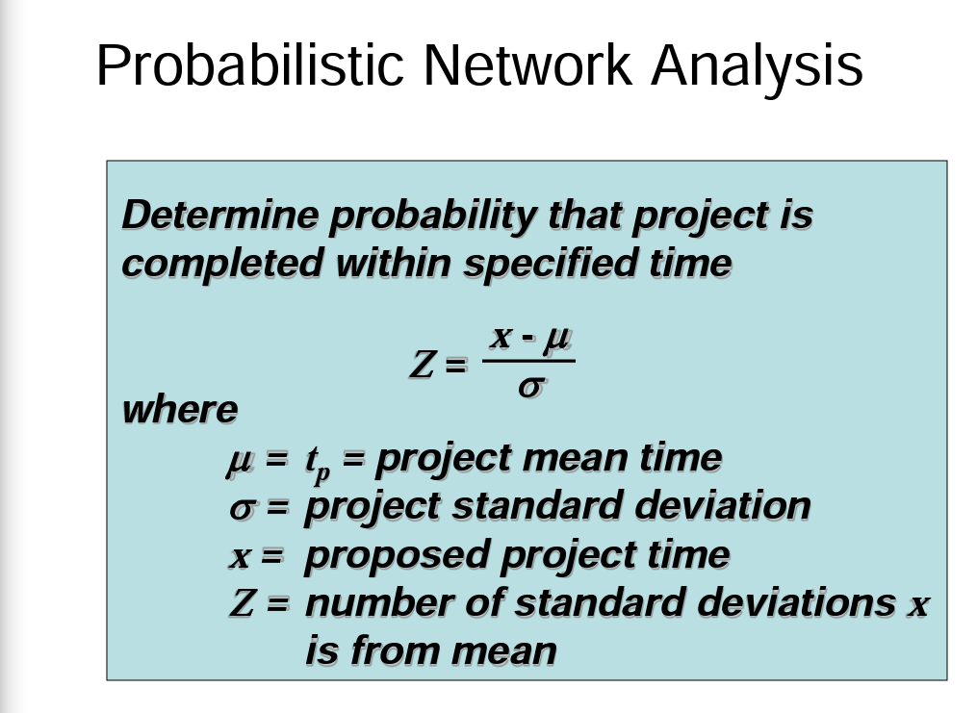
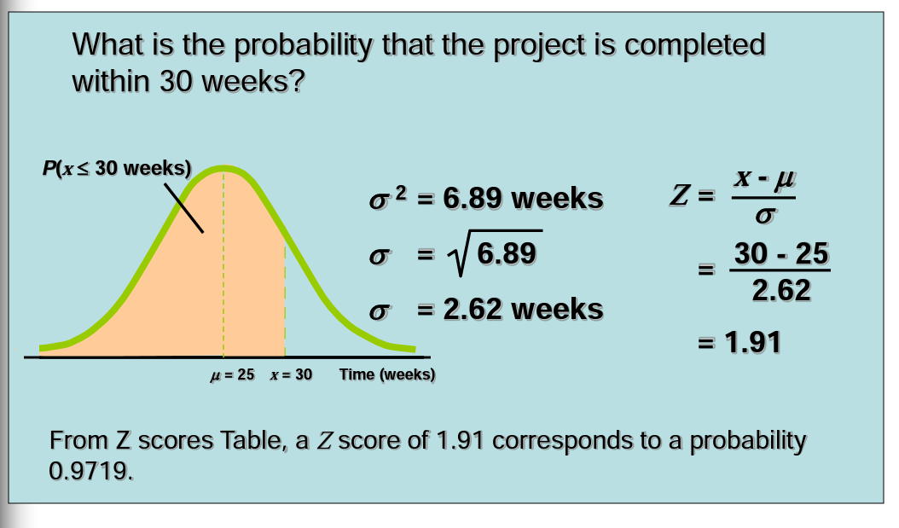
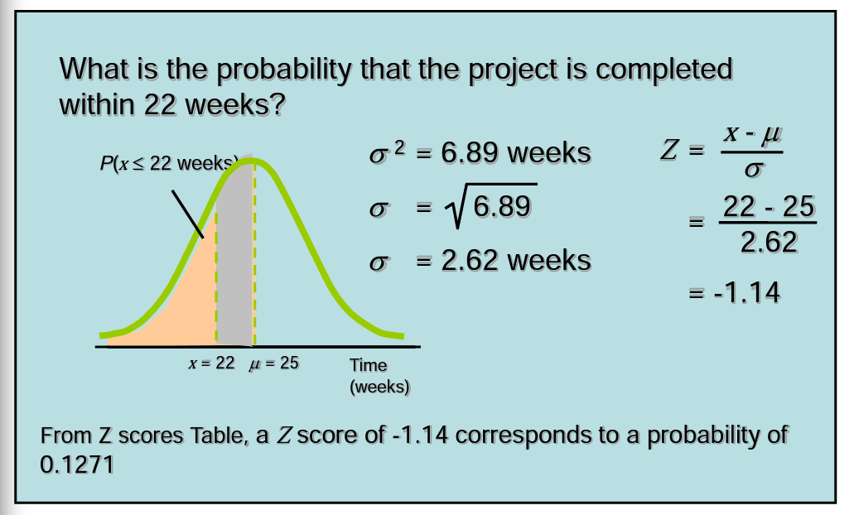
Now probability that project will complete in 41.5 weeks is

(41.5-42.833)/ s= -0.538; variance=221/36=6.13; standard deviation =2.47
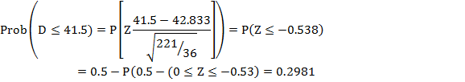
Similalry Now probability that project will complete in less than 44 weeks is

Z score (44-42.833)/2.47= 0.471
P value 0.680

